Radar Live Reconciliation – Knowledge Share and Handover
Oct 12, 2026 · @Vino

About this document
This document hands over the Radar Live reconciliation: what it is for, how it works, how to run and support it, and what is still open. It explains the design and the reasoning behind it, so a new owner can maintain and extend it without having to reverse-engineer the notebooks.
Item | Detail
Audience | Data engineers taking over the job; analysts and support teams who use its results
Covers | The MQS and Interaction reconciliations, their output tables and the dashboard
Does not cover | How the Athena file, the MoveIT transfer and the eHub streams are produced (upstream systems)
Related documents | Radar Live Reconciliation requirements specification; Support Matrix
Handed over to | TBC
The code itself is the reference for exact column lists and logic. This document gives the mental model needed to read it.

Why the reconciliation exists
The reconciliation is a daily control that proves every quote requested in Athena has reached the Allianz Personal (AZP) data platform. It was introduced when quote processing moved from the Polaris rating engine to Radar Live and the Master Quote Service (MQS), because nothing confirmed that data sent from Athena actually arrived.
Without it, missing or incomplete quote data could go unnoticed and affect reporting, operations and regulatory obligations such as General Insurance Pricing Practices (GIPP) reporting. The control aims to:
- Ensure completeness: every quote from Athena is captured on the platform.
- Build trust: the platform can be relied on as the source of truth downstream.
- Support decisions: reporting and analytics run on complete, timely data.
- Reduce risk: gaps are found and fixed before they affect compliance or customers.

How it works at a glance
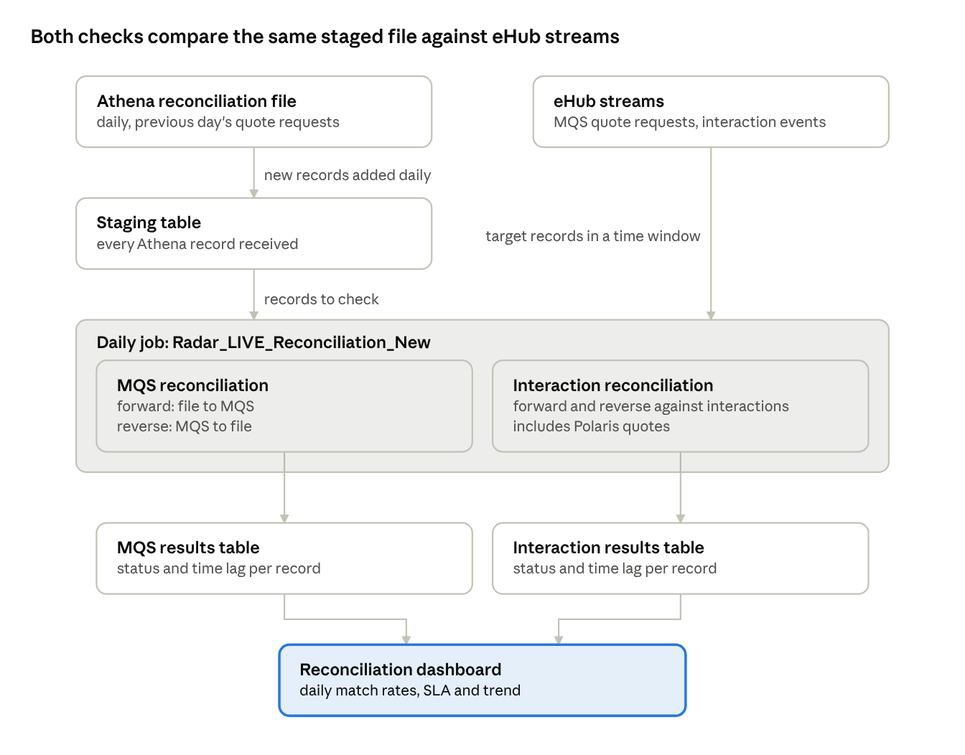
end-to-end flow · 2 sources, 2 checks, 1 dashboard
The Athena file is staged once and shared; each reconciliation reads its own eHub stream, writes its own results table, and the dashboard reads both.

Key concepts
Both reconciliations are built from the same handful of ideas. Once these are clear, the notebooks read as variations on one pattern.
Concept | What it means
Source of truth | The daily Athena reconciliation file: one record per quote request from the previous day
Target system | Where the record should have arrived: MQS quote requests, or interaction events, both read from eHub streams
Forward check | Starts from each Athena record and asks: did it arrive in the target system?
Reverse check | Starts from each target-system record and asks: is it in the Athena file?
Match rule | Records pair when their identifiers agree (interaction ID, quote ID where present, transaction type) and their timestamps fall within a time window of each other
Time window | How far apart in time the two events may be and still count as the same quote. It absorbs processing delays and late-arriving data
Closest match | If several candidates qualify, the one nearest in time wins, so each record produces exactly one result
Transaction code | Athena's transaction type (New Business, Renewal, MTA) is translated to the code the target system uses, so the two can be compared
First run vs incremental run | The first run reconciles all history; later runs re-check only the most recent few days, which also catches data that arrived late
Segment | Interaction only: records with an MQS quote ID are MQS-linked; records without one are treated as Polaris (non-MQS) quotes and matched among themselves
Status | Each result is labelled matched or missing, per direction, with the time lag between the two events

Components and where they live
Everything runs in Databricks under one job, with the catalog taken from the environment, so the same code serves every environment.
Component | What it is | Purpose
Radar_LIVE_Reconciliation_New | Databricks job | Runs both reconciliations daily
MQS reconciliation | Notebook task | Loads the Athena file and reconciles it against MQS
Radar_Live_Interaction_Recon | Notebook task | Reconciles the same Athena records against interaction events
Landing volume raw/structured/radarLiveSourceReconciliation | Unity Catalog volume | Where the daily Athena file arrives via MoveIT
radar_live.reconciliation_csv_source | Delta table (staging) | Every Athena record ever received; shared by both reconciliations
radar_live.recon_mqs_details | Delta table (output) | MQS reconciliation results
radar_live.recon_interaction_details | Delta table (output) | Interaction reconciliation results
RadarLive-MQS Source Reconciliation | Databricks dashboard | Daily view of reconciliation rates and SLA
The target systems are read from eHub stream tables owned upstream: the MQS stream for quote requests and the flow stream for interaction events. Notebook paths are recorded in the handover checklist.

MQS reconciliation: how it works
The MQS notebook does two jobs: it brings the Athena file into the platform, then reconciles it against MQS quote requests. It runs in four steps.
- Set up the environment. The notebook picks up the current catalog and reads a load-mode setting: normal (latest file only) or full reload (every file in the folder).
- Find the file. It looks in the landing volume for files following the agreed naming pattern (data_reconciliation_DDMMYYYY.csv, where the date is the interaction date) and picks the most recent.
- Stage the records. The file is read, a request timestamp and transaction code are derived for each row, and only rows not already staged are added. Staging is insert-only, so it builds up a full history and re-running is safe.
- Reconcile and save. The notebook:
  - Chooses which Athena records to check: everything on the first run, then the latest few request dates on later runs.
  - Reads MQS quote requests from a window around those records' time range.
  - Runs the forward and reverse checks using the match rule and keeps the closest match per record.
  - Calculates the time lag between the two events.
  - Writes the results to recon_mqs_details. The first run builds the table; later runs merge into it, updating existing results and adding new ones.
Why it is built this way
- The insert-only staging table keeps a full history independent of file delivery, so files can be reprocessed or rebuilt at any time.
- Re-checking recent days lets records that arrive late in MQS move from missing to matched without manual intervention.
- The time window keeps the MQS read small and prevents unrelated quotes with reused identifiers from pairing up.
- Doing both directions means gaps are visible whichever side they occur on.

Interaction reconciliation: what is different
The Interaction reconciliation follows the same pattern as the MQS one, but compares the Athena records with interaction events instead of MQS quote requests. It has no ingestion step of its own: it reads the staging table the MQS task loads, so it must run after that task.
The differences that matter when supporting it:
- It covers all quotes, including Polaris. Records without an MQS quote ID are kept and matched only against interaction events that also lack one. The MQS reconciliation leaves these out, so between them the two checks cover every quote.
- The transaction type comes from the interaction's process. Process names such as new business, renewal, MTA and support are mapped to the same codes as the Athena file. Events with an unrecognised process are ignored.
- The time window is the same in both directions, so forward and reverse results are directly comparable.
- The first run has no time window. It matches across all available history and can show long lags; later runs apply the window as normal.
- The source is de-duplicated before matching, keeping the latest copy of each event from the stream.
- Results carry more context, including event type, status, agreement number and the quote's pricing dates, to help investigate gaps.
- The source stream is read from a fixed catalog rather than the current environment, and from a fixed start date; both are worth making configurable.

Settings you may need to change
A few settings at the top of each notebook control the behaviour; everything else follows from them.
Setting | What it controls | When you might change it
Load mode (is_full_load) | Latest file only, or every file in the folder | To pick up missed or re-delivered files
Lookback days | How many recent request dates each run re-checks | If data routinely arrives later than the lookback covers
Scan days before / after | The time window for matching and for reading the target system | If genuine matches fall outside the window, or to reduce run time
Start date (Interaction only) | Earliest interaction events read | Once older history is no longer needed
Table names and catalog | Where data is read from and written to | When moving environments or renaming objects
Wider windows find more late matches but read more data and run longer. Changing the window or match rule changes what counts as a match, so agree it with the business and note it in the change log.

Running, operating and support path
The job runs daily after the Athena batch and file transfer complete; a normal run needs no intervention and is safe to re-run.
Situation | What to do
Normal day | Nothing; check the dashboard
File was late or missed | Once it lands, re-run the job; for several missing days, run with full reload
Results look wrong after a logic change | Clear the output table and re-run; the first run rebuilds it from the full staged history
Need to re-check older dates | Rebuild as above, or temporarily increase the lookback
Job reports no valid records | Check the file arrived and is populated
After each run, confirm that:
- ☐ Both tasks succeeded
- ☐ New records were staged for the latest file
- ☐ The dashboard shows the latest date for both reconciliations
- ☐ Forward reconciliation is within the SLA
Support path: BICOE MI App Support first; check event hub health using the Dynatrace dashboard metric. If it is not a data platform issue, escalate to the relevant Application Support team using the Support Matrix.

Reading the results and the dashboard
Forward reconciliation is the primary measure of completeness; reverse reconciliation is currently informational, because the Athena file does not yet cover every brand that MQS receives.
Status | Plain meaning
Matched in MQS / Interaction | The Athena record arrived in the target system
Missing in MQS / Interaction | The Athena record has not been found in the target system within the time window
Matched in CSV | The target-system record has a matching Athena record
Missing in CSV | The target-system record has no Athena record in the period checked
The dashboard (RadarLive-MQS Source Reconciliation) has three tabs: Reconciliation – MQS, SLA Analysis – MQS, and Reconciliation – Interaction. Each shows the latest forward and reverse percentages against a 99% SLA, a daily table of totals and matches, and a trend over recent months.
- Forward % = Athena records matched ÷ Athena records checked.
- Reverse % = target records matched ÷ target records checked.
Why reverse is low. The Athena file currently contains AZ Motor quotes only, while MQS also receives Britannia quotes. Britannia records have nothing to match in the file, so they appear as missing in CSV and pull reverse well below forward. This is a known scope gap, not data loss. A future release will add Britannia to the same file, after which reverse should move close to forward and the reverse SLA should be re-baselined.
Reading a record's history. When a record that was missing arrives later, a new matched result is written while the earlier missing result remains (see Known limitations). When counting exceptions, use the latest result per record.

Troubleshooting guide
Most issues trace back to the file, the upstream stream, or timing; work through those before suspecting the reconciliation logic.
Symptom | Likely cause | What to do
Forward % drops sharply for one day | Athena file late, empty or partial | Check the file landed and its record count; re-run once it is complete
Forward % drops to zero | No file, or the job did not run | Check MoveIT delivery and the job run history
Many records missing in MQS / Interaction | Upstream stream delayed or down | Check event hub health (Dynatrace); results recover on later runs once data arrives
Specific records missing despite existing upstream | Identifier mismatch, transaction type not mapped, or event outside the time window | Compare the record's IDs, type and timestamps on both sides
Reverse % low across the board | Britannia quotes not yet in the Athena file | Expected; investigate only AZ Motor misses
Lags off by about an hour | Time zone or daylight-saving difference between the two systems | See Known limitations
Job fails at file discovery | No file matching the naming pattern in the landing folder | Check the file name and folder
Interaction results empty or stale | Interaction task ran before the MQS task finished staging | Check task order in the job

Known limitations and improvement backlog
The reconciliation works as a daily control today. The items below make its numbers more precise and close the remaining gaps against the requirements; the first three have the most effect on reported figures.
# | Item | Why it matters | Suggested direction
1 | Earlier "missing" results are kept when a match arrives later | Exception counts are overstated unless the latest result per record is used | Key each result on the record being checked only, so its status updates in place
2 | In the MQS reconciliation the forward and reverse time windows are not mirror images | The same pair can be matched one way and missing the other way | Use the same window in both directions, as the Interaction reconciliation does
3 | The reverse check looks at a wider time range than the Athena records being checked | Records near the edges can be reported missing in CSV | Align the reverse range with the Athena records in scope
4 | Time zones are not aligned between Athena and the streams | Lags and window edges can be off by an hour during daylight saving | Agree each source's time zone and convert both to one standard
5 | The Athena summary count file is not used | No check that the detail file itself is complete | Compare detail record counts with the summary count each day
6 | No dedicated exception output | Users filter the full results table to find gaps | Publish an exceptions view based on the latest result per record
7 | Some settings are fixed in code (catalog, start date, file selection by modified time) | Harder to move environments or reprocess safely | Make them parameters
8 | Reverse reconciliation excludes Britannia from the file side | Reverse % is not yet a true completeness measure | Re-baseline once Britannia is added to the file
Requirements coverage. The core detail-file comparison, daily schedule, previous-day window and Polaris handling are in place. Items 1, 5 and 6 above correspond to requirements not yet met: late-arriving IDs removed from exceptions, the summary count check, and the exception table. Daylight-saving handling (item 4) is still an open question in the requirements themselves.

Handover checklist
The incoming owner should complete these before taking sole ownership.
- ☐ Walk-through session covering both notebooks, the job and the dashboard
- ☐ One supervised daily run, including the post-run checks
- ☐ Record notebook paths, job schedule and dashboard refresh schedule
- ☐ Confirm access to the landing volume, staging and output tables, eHub streams and the dashboard
- ☐ Confirm the Interaction task runs after the MQS task
- ☐ Confirm the time zone used by Athena and by each stream
- ☐ Confirm the transaction-type mapping covers every value Athena and the streams send
- ☐ Agree priority and owner for the improvement backlog, starting with items 1–3
- ☐ Plan the reverse SLA re-baseline for when Britannia joins the Athena file

